Some of you may have noticed a new tool in the Gale InfoTrac products. Term clusters, or visual search results, organize results based on frequently recurring terms and allow users to discover hidden connections. Term clusters can be used to expand or narrow a topic, identify new topics of interest, guide research structure, and more.

After doing a search in PowerSearch, InfoTrac Student, InfoTrac Junior, InfoTrac Newsstand, and other InfoTrac databases, you will see “Term Clusters” under “Analyze” in the column on the left. Click on that to see a visual representation of related topics. For an example, see the next three pages.

To learn more about how to use term clusters and for a complete list of which Gale databases include the tool, refer to this tip sheet. The help section of the InfoTrac databases, under “Ways You Can Search,” also offers an explanation.
http://assets.cengage.com/training/TermClusters_TipSheet.pdf

Please let students and educators know.

Thanks,
Jen

Jennifer Maurer
School Library Consultant
Oregon State Library
250 Winter Street NE
Salem, OR 97301
503.378.5011
jennifer.maurer@state.or.us

- After completing a search in an InfoTrac product, click on “Term Clusters” in the column on the left.
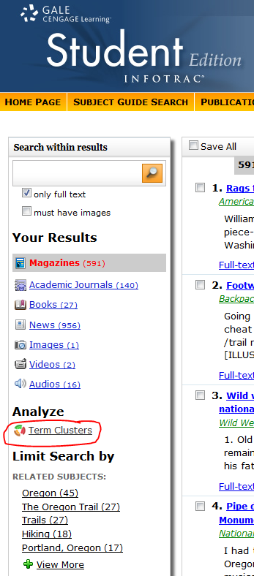
- Review the “suggestions” in the term cluster and click on one as a way to expand or narrow a search. (For example, maybe “Corps of Discovery” under “American Indians”)

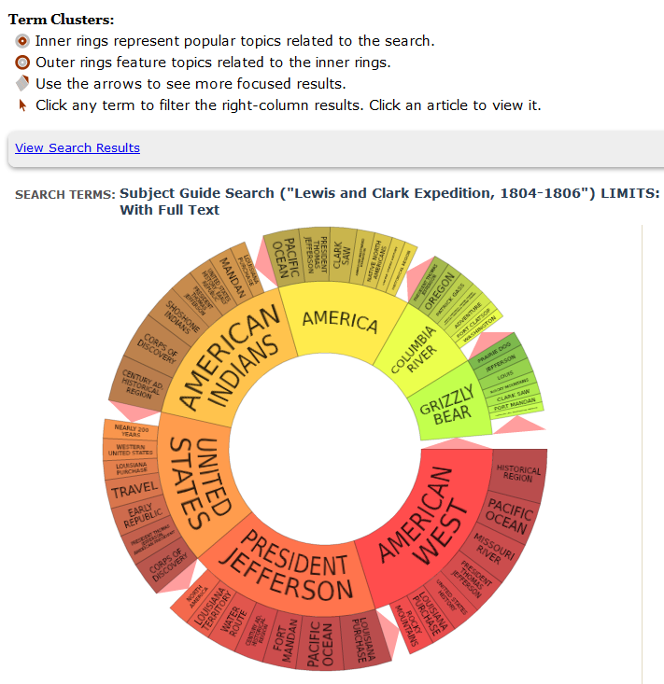

- Browse the new results on the right.

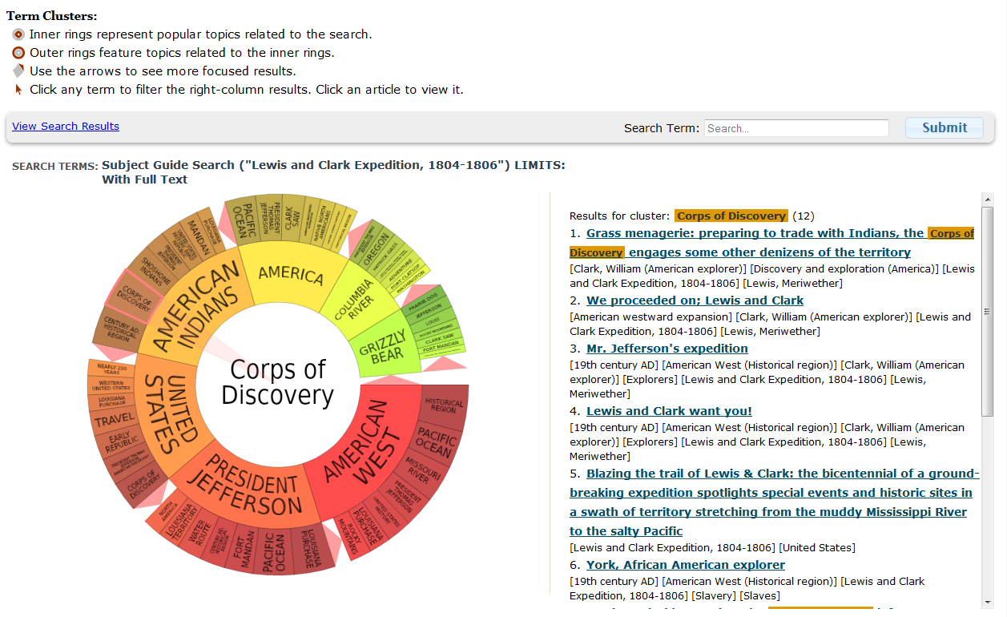

Or, start your search by first clicking on Term Clusters in the orange toolbar at the top of the page. Then do steps 2 & 3 above.
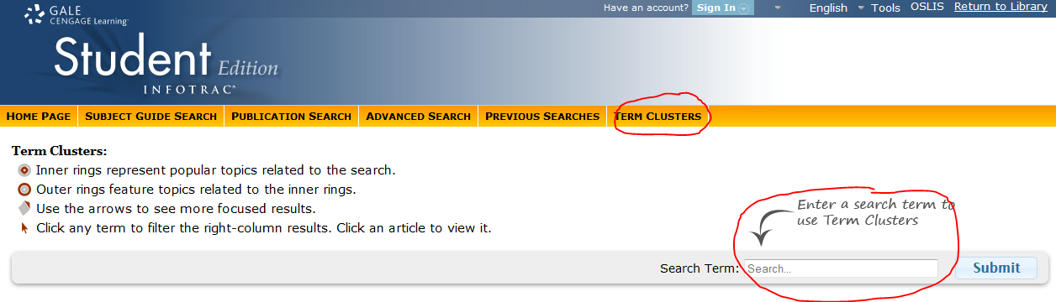

--end--

