2.17.15

Most Gale databases offer the ability to have an article read aloud using text-to-speech technology. While the feature, called ReadSpeaker and labeled Listen, is machine-driven, it provides very good audio. You can find the option towards the top left side of nearly any Gale article.



Here are three tips for using the Listen feature.

- When you click on the orange-red arrow, ReadSpeaker starts at the beginning of the article. However, you can also highlight a section of text and then click on the ReadSpeaker arrow to have only the highlighted text read aloud.
- After you activate ReadSpeaker, click on the gear to change such settings as the text color, reading speed, and highlighting options (word and sentence, word only, and more).
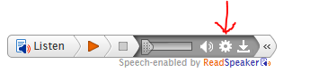
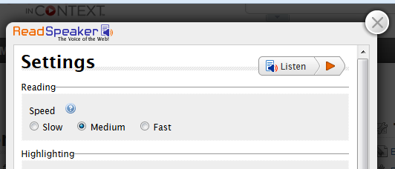

- If you translate an article and then click on Listen, the article will be read aloud in the translated language.

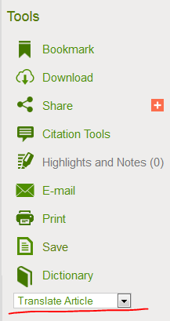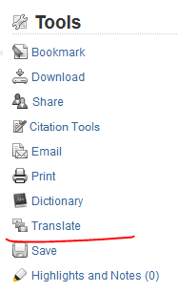

Who might want to know about this? Struggling readers, teachers of ELL students, educators preparing students for the listening portion of the Smarter Balanced tests, those studying a foreign language, and more.
Questions? Please ask.

This information is also available in the OSLIST archive: http://oslis.org/oslissupport/announcements.
Thanks,
Jen

Jennifer Maurer
School Library Consultant
Oregon State Library
250 Winter Street NE
Salem, OR 97301
503.378.5011
jennifer.maurer@state.or.us

OSLIS || www.oslis.org
Learn to research. Research to learn.

FOLLOW US:

