Highlights and Notes

As eBooks and digital resources have become more popular, a problem has presented itself: how can a user easily take notes without opening a separate program? Gale has found the solution with our new Highlights and Notes tool, which is available in the following databases:
- Kids InfoBits
- GVRL
- In Context products (Opposing Viewpoints, Student Resources, and U.S. History)
- InfoTrac products (PowerSearch, InfoTrac Junior, InfoTrac Senior, Informe, Academic OneFile, General OneFile, and more)
The new tool allows users of the digital resources listed above to select text from an eBook or article, highlight the important sections, add their own notes, and save it to a new Highlighted Articles page where it can be accessed or exported, during each user’s session (no user account required).
Researchers will utilize their critical thinking skills by finding important information in multiple sources and marking the relevant facts in each. Within the same session, the highlighted sections can be easily viewed, printed, downloaded, or sent via email. Highlights and Notes is the perfect tool for anyone conducting research in Gale’s products.
Below is a step-by-step guide to using the Highlights and Notes tool.

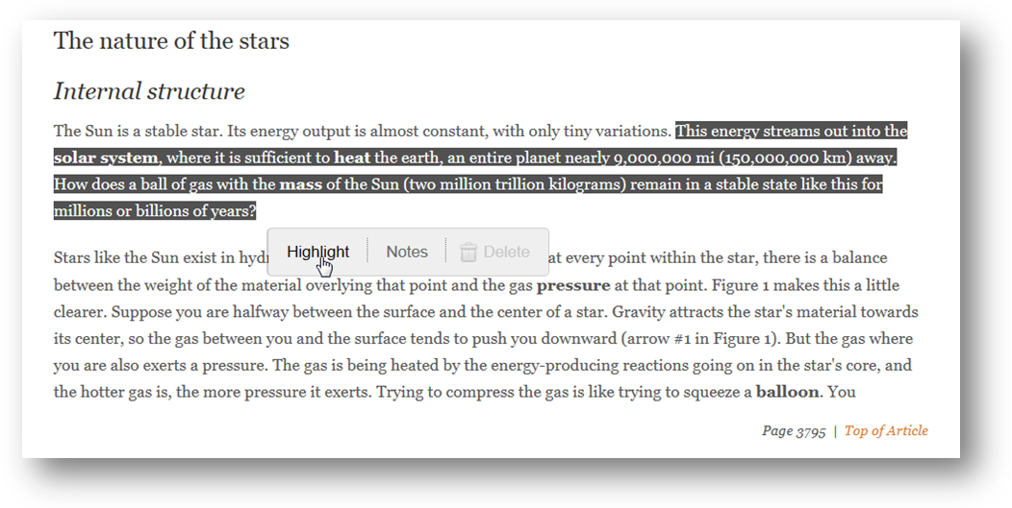1. Select the text you would like to save, and then click Highlight.
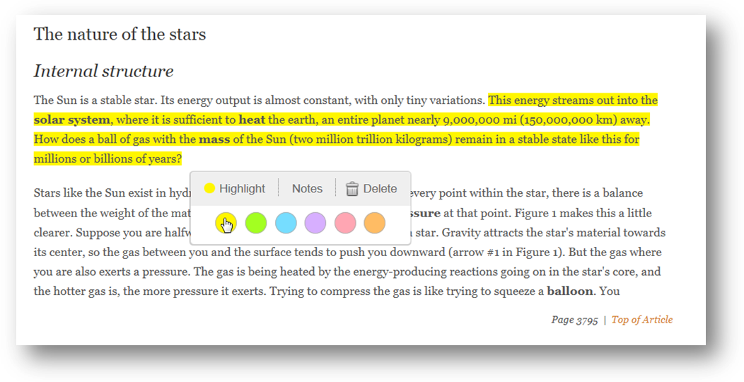
2. Assign a color to the highlighted text; there are six options.

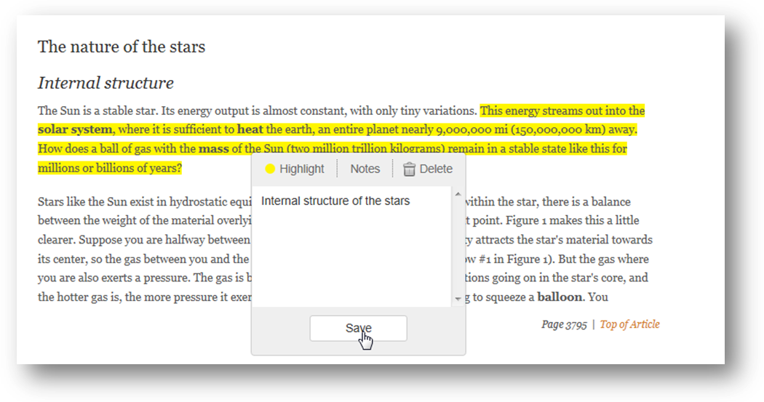3. To add Notes, click on the Notes tab, enter the text, and click on Save.

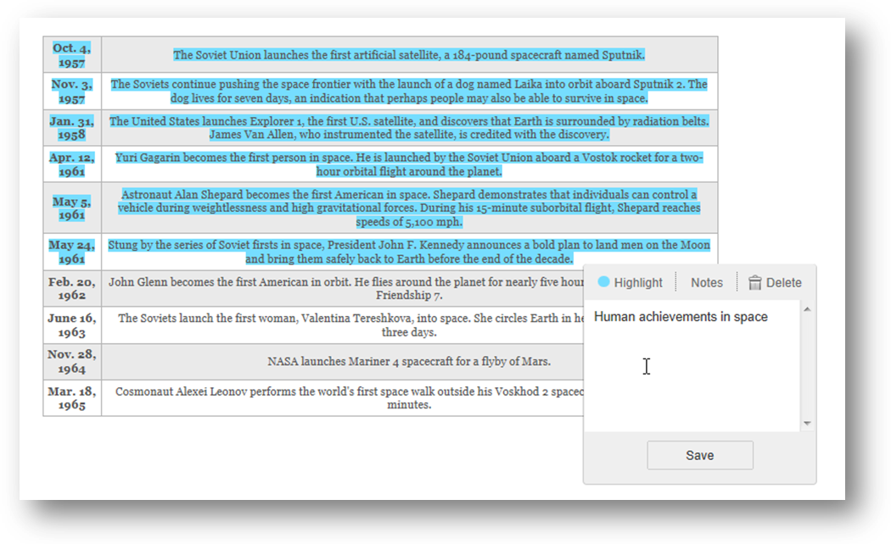 Idea: Keep your highlighted sections organized by using different colors for each publication, resource, or article.

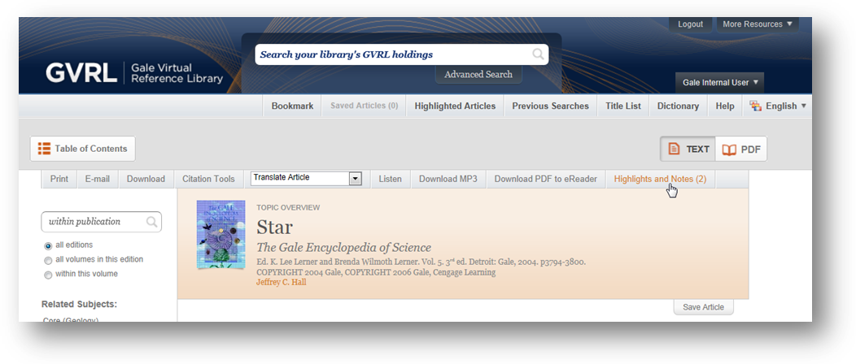4. To view all of your highlighted sections for the session, click the Highlights and Notes button in the toolbar at the top of the page. That is true for GVRL and InfoTrac products.
For Kids InfoBits, the option is under Tools at the top of the page.
For In Context products, there is a link above the search box called Highlighted Articles.
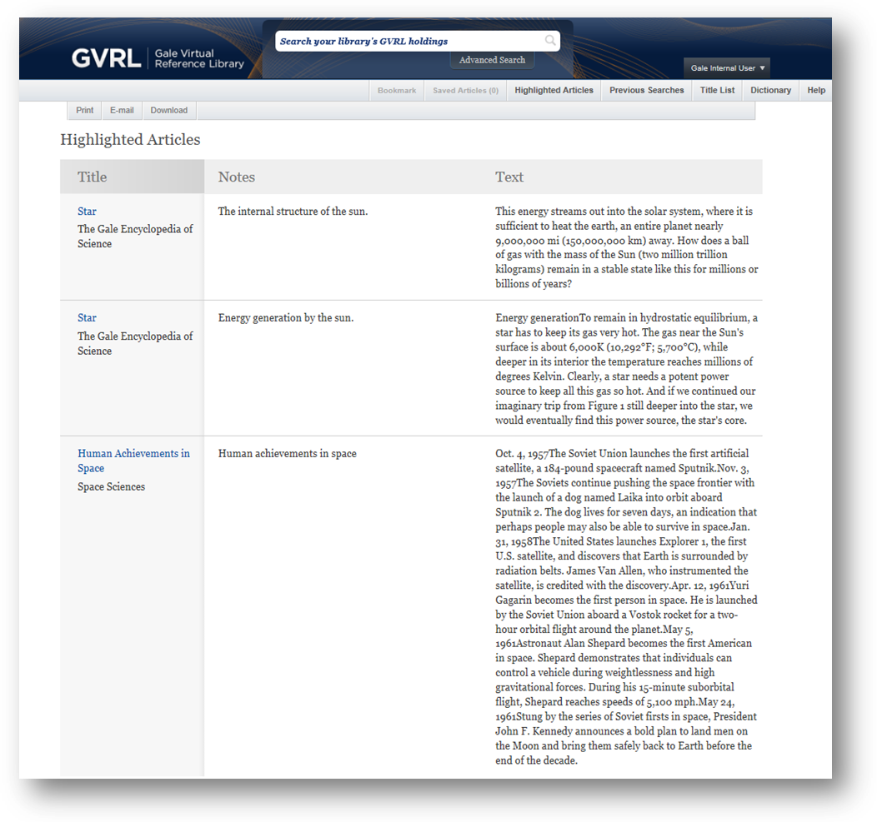5. The Highlighted Articles page shows all of your highlighted sections and notes, including the name of the source publications. You have the option to print, email, or download the list. Remember that once you close out of the session, your highlighted sections and notes will be gone.

